**Objectives**

**Explain git ignore**

The “.gitingnore” file in a Git project is used to tell Git which files or folders should be ignored and not tracked. This helps avoid adding unnecessary or sensitive files (like temporary files, logs, or system-specific files) to the version control history.

**Explain how to ignore unwanted files using git ignore**

To ignore unwanted files, you simply list their names or patterns inside the “.gitignore” file. Once added, Git will stop tracking those files, keeping your repository clean and focused only on relevant source code and project files.

**Create a “.log” file and a log folder in the working directory of Git. Update the .gitignore file in such a way that on committing, these files (.log extensions and log folders) are ignored.**

**Verify if the git status reflects the same about working directory, local repository and git repository.**









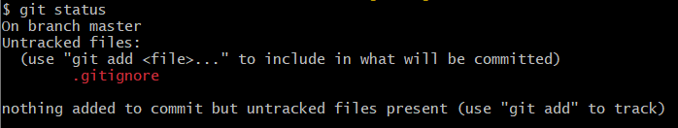



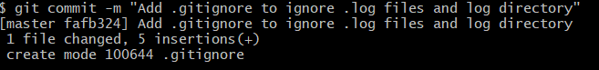

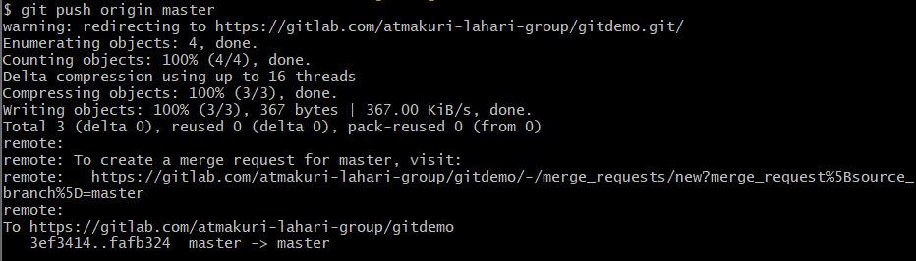

**Output:**

